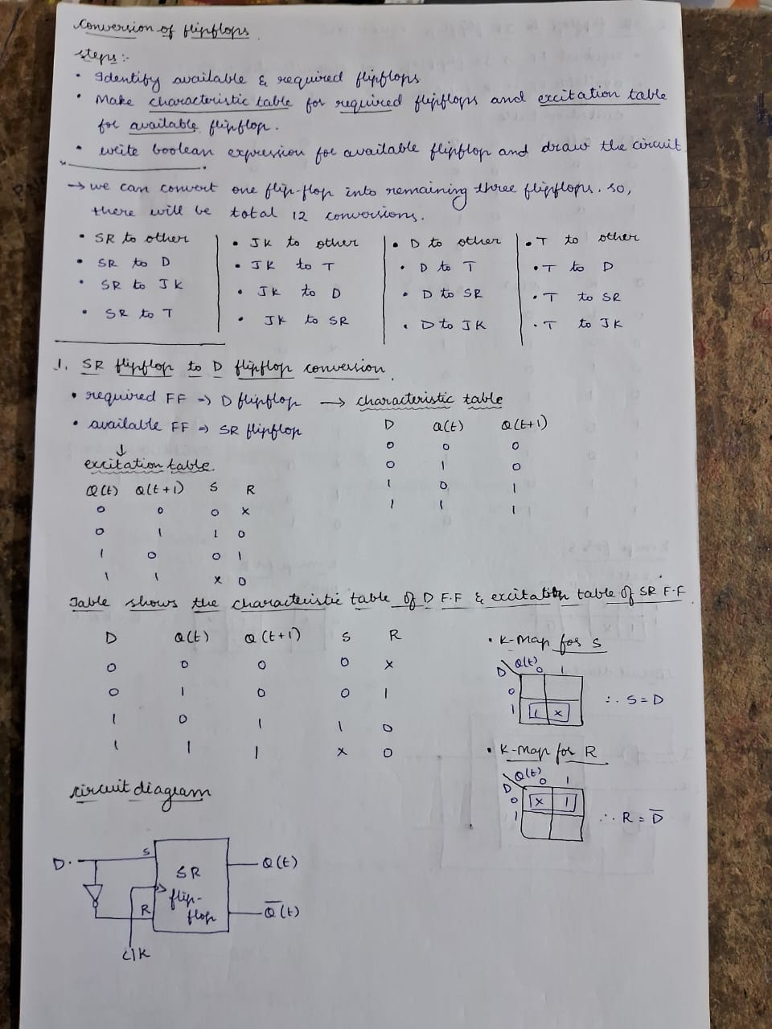

By Sri Pranathi Challagolla

**Conversion of Flip-flops**

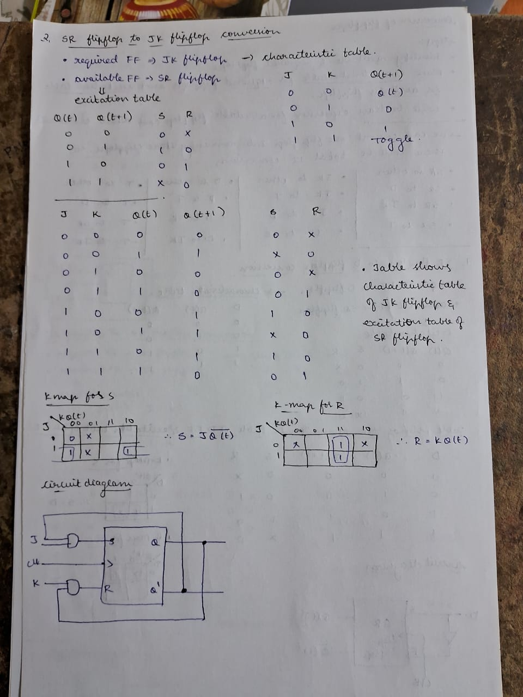

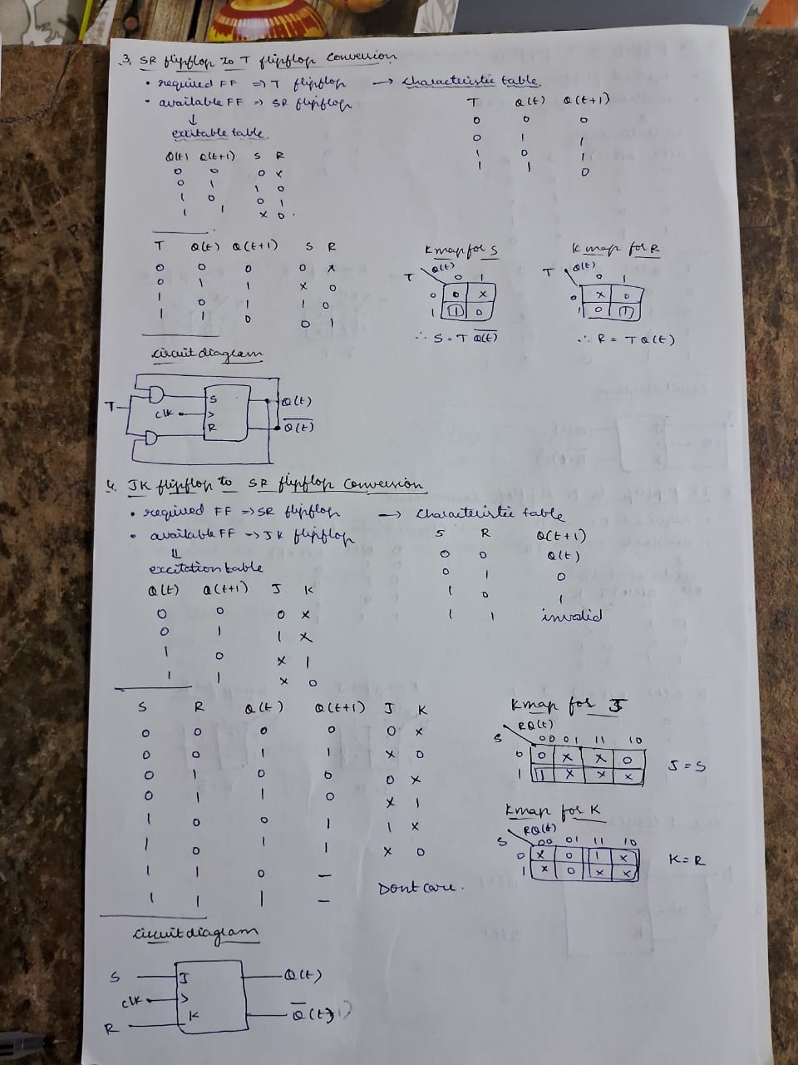

**Testbench:**

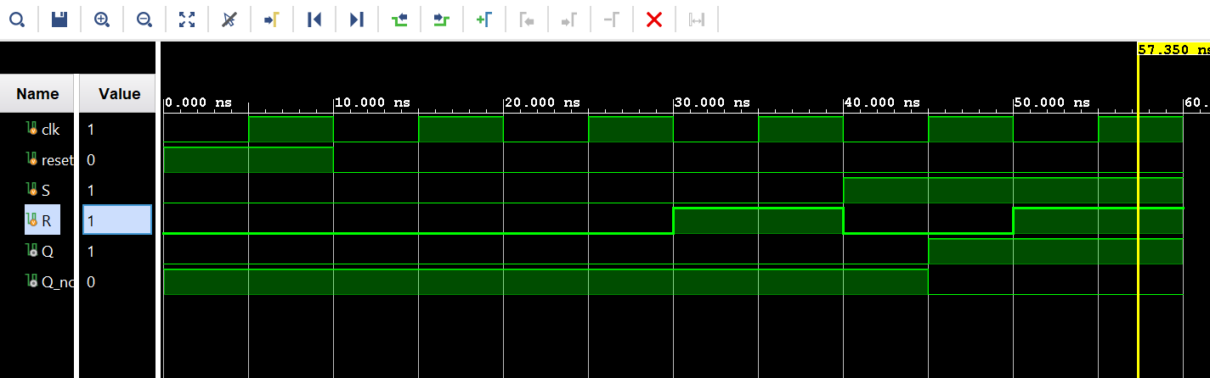

**1.Implemented D flipflop to SR flipflop conversion using Verilog:**

**Design:**

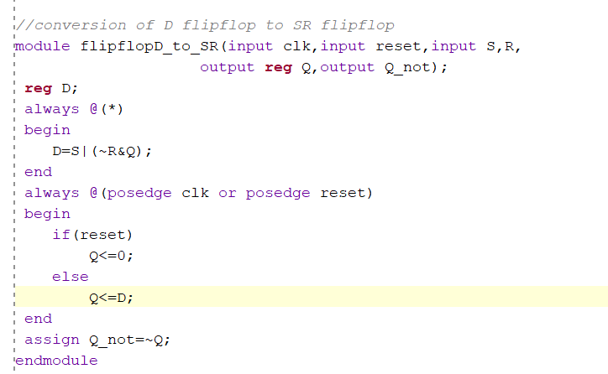

**2.Implemented T flipflop to D flipflop conversion using Verilog:**

**Design:**

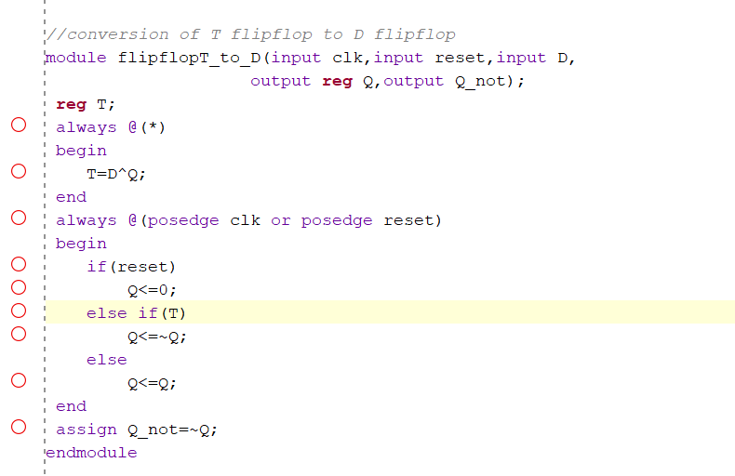

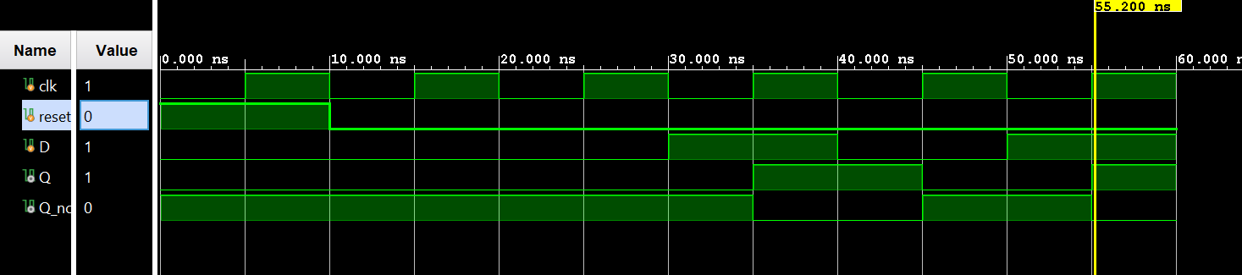

**Testbench:**

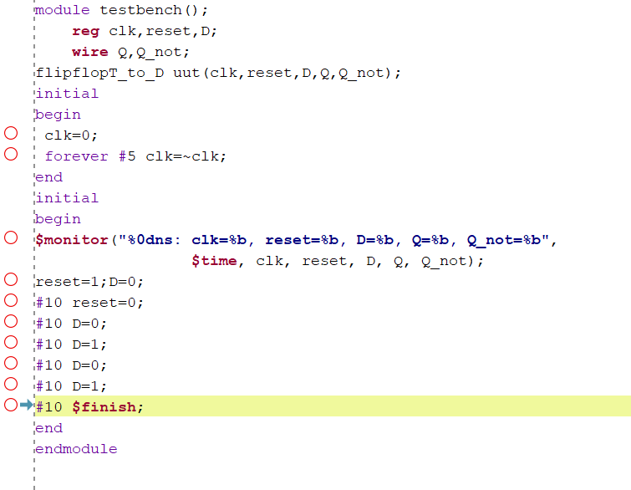

**3.Implemented JK flipflop to SR flipflop conversion using Verilog:**

**Design:**

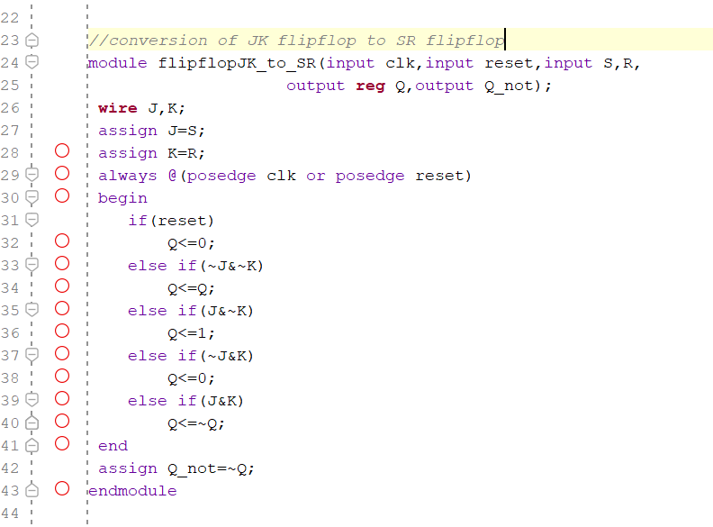

**Testbench:**

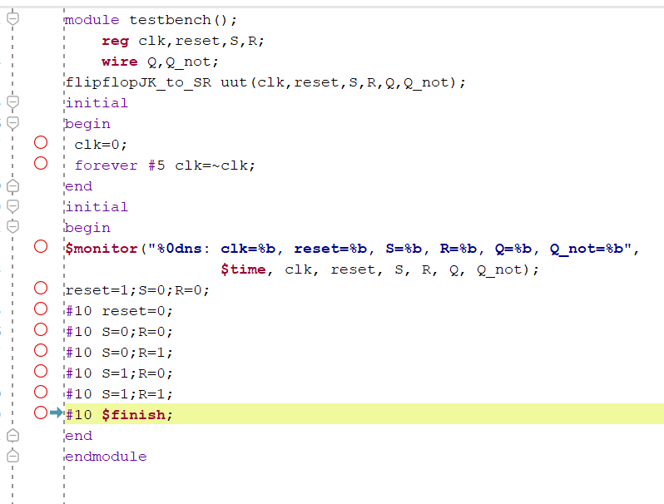

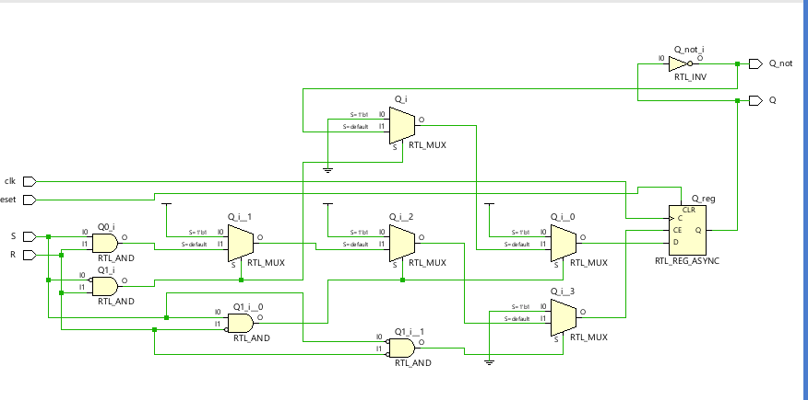

**4.Implemented SR flipflop to D flipflop conversion using Verilog:**

**Design:**

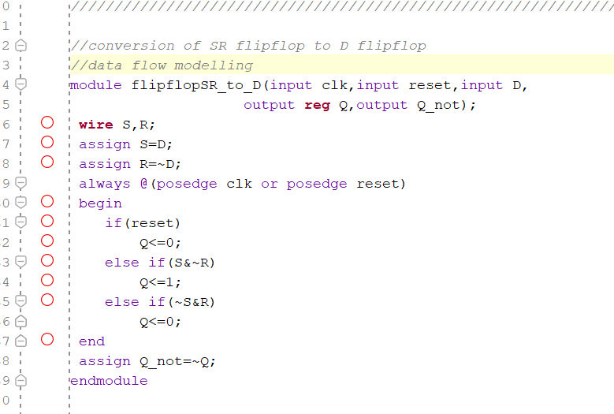

**Testbench:**

